|  |  |  |  |
| --- | --- | --- | --- |
| **SPMI** | **FORMULIR PROSEDUR AKADEMIK** | **No** |  |
| **BAHAN RAPAT TINJAUAN MANAJEMEN** | **Revisi** |  |
| **Tanggal** |  |
| **Halaman** | **1/1** |

**AGENDA RAPAT TINJAUAN MANAJEMEN**

|  |  |
| --- | --- |
| No | Laporan Temuan |
| 1 | tes laporan temuan |
| 2 | testing |

Semarang, 3 Maret 2022

Kepala PPMP

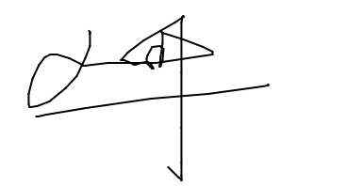

Pimpinan PPMP